Looking back over Gorriti’s exhibition in MoMA Machynlleth
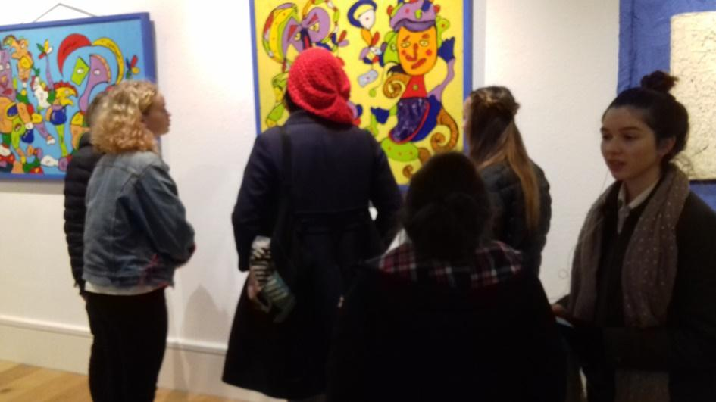
“It changed my life,” said Myfanwy Fenwick simply, when I asked her what she thought of Gorriti’s exhibition in Machynlleth. Myfanwy is a fifteen-year old schoolgirl, who was entranced by Gorriti’s vivid use of colour and vibrant folk images. A classmate of hers, Alaw Jones, took a wider view; “I never realised till now where Euskal Herria was, that they are a small country like us, and that they love their language and culture as much as we love ours.”
Gorriti’s exhibition was a revelation. In these cloudy islands, the exuberance of his work was a powerful experience, and at the same time the themes and ideas he explores struck many chords with the audience in this very agricultural area. Twenty school students who had enjoyed his work in the gallery, and watched his films on video, went on to create their own ‘ganbara’ – Gotrriti’s tactile image of homely poverty - in a two-day workshop led by the Welsh artist Luned Rhys Parri.
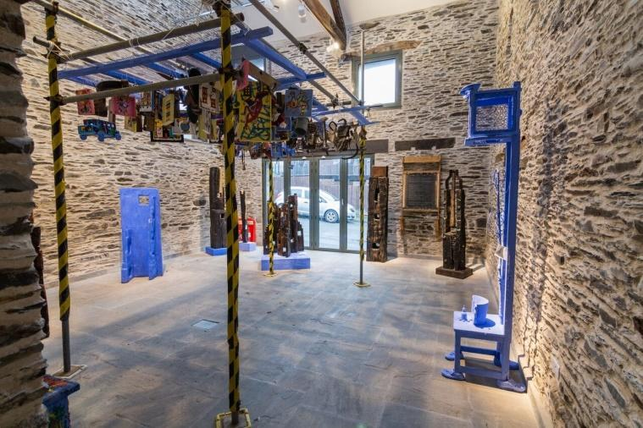
“This re-used, recycled, upcycled visual extravaganza,” said teacher and graphic designer Elinor Wigley, “awakens memories of times gone by, a childhood rich in culture – and that blue – don’t forget the blue, the blue!” “It re-inspired the child in me,” said Angela Gillen, who lives a few miles away. “There is something so spontaneous, and so honest about it that it blows your inhibitions and your cynicism away.” “Gorritis work is an inspiration to all smaller language speakers,” said Naomi Heath, who has herself exhibited in Lekunberri, “and a , testament to the community he is from. Gorriti’s art is in essence the Basque country itself.”
Allan Wynne Jones commented on the artist’s essential humbleness; “he doesn’t posture like an ‘artist’,” he said. “He just shares his feelings and perceptions with you, one person to another.” The Welsh artist Marged Pendrell was greatly moved by Gorriti;s art, commenting “Gorriti’s exhibition in Moma Machynlleth was a portal into the rich tapestry of colour ,forms and symbolism of the Basque culture. The installed juxtaposition of found objects and created sculptures evoked memories of my own childhood in rural Wales ,as well as giving a fresh and inspiring insight into his imaginary and physical world”

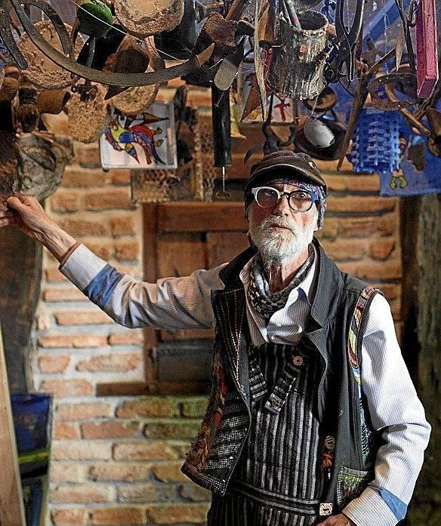
At first it might seem a strange thing, that so complete and ambitious an exhibition by a famous Basque artist should come to a small town in mid-Wales. And of course, luck and coincidence were involved in this process – a chance meeting between Gorriti and myself a year before had led to this, and the fact that Gorriti was staging a fifty-year retrospective in Donostia made the logistics much simpler than they might have been. But in another way, it was not strange at all; contacts have been growing up between the two cultures for nearly twenty years, with musicians and artists moving both ways across the bridges we’ve built, and over that time both Welsh people and Basque people have come to realise how much we have in common – culture, landscape, language and way of life.
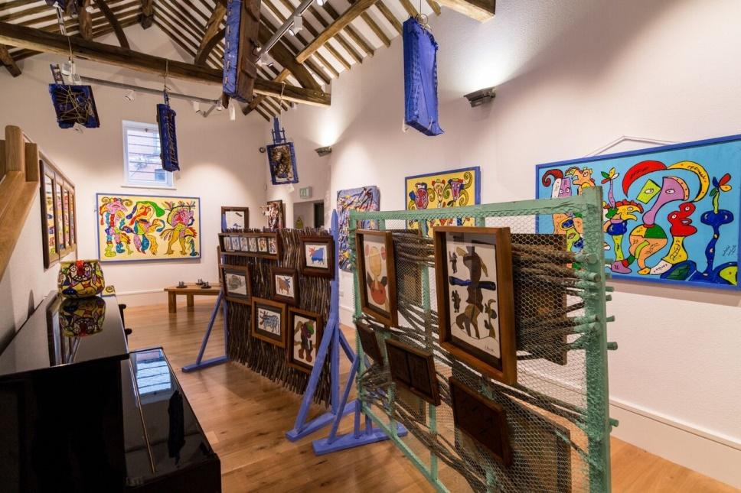
Gorriti’s exhibition was the centrepiece of a powerful Basque contribution to our quiet winter last year. In addition to his work, we hosted a wonderful smaller exhibition of rural arts and crafts from Nafarroa, sent across and introduced by Ana Andueza from Plazaola in Gorriti’s home town of Lekunberri. We had concerts by the Basque musicians Bitartean and Bidaia, a film in out two languages by Uxue Arzelus from Donostia, lectures and discussions and much more. The shops offered discount to people who could order in Euskara, and the school students acted as translators and mentors. Gorriti’s work was the focus and inspiration of everything else happening in our corner of Wales at that time; but even such powerful experiences do not take place in isolation – and their value would be lessened if they did. Partly as a result of her contacts with Gorriti before it took place, the north Wales artist Luned Rhys Parri undertook a month’s residency in Lekunberri this spring, working and walking with him on a number of occasions. “Gorrit sees the world in a very similar way to me,” she commented on her return. “It was a great experience wandering round the farms with him, meeting shepherds and cheese makers and getting a taste of traditional life there.” Luned will be returning this autumn with her finished work, and also a small group of actors and musicians, to share her visions with the community that inspired her, and give them a taste in turn of contemporary and traditional Welsh culture.
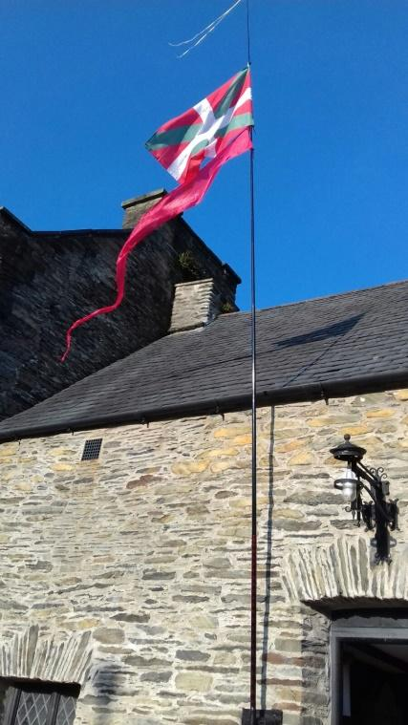
So the interaction continues, gathers pace, deepens and draws us all further into each other’s lives and cultures. Without the help of friends here, including above all the Arts Council of Wales, and others in the Basque Country, most notably Jabier Lekuona , this exhibition could never have happened. Together, we are proving the truth of Gorriti’s vision when he visited Wales for the first time last year. “Gales eta Euskal Herria – bat!” he asserted. Wales and Uskal Herria are one.

