Can y Bugail - moving forward independently

For some time Celtic Neighbours; flagship project, this initiative aims to build sustainable links of culture, language and livelihood between farming communities in the marginalised regions of Europe. It has spawned a number of satellite projects including ‘Hansel’ the exchange of unsolicited gifts between communities, a series of physical/ digital symposia over the next two years, and most recently a travelling exhibition of wool-related artwork, products and craftwork. Partners eager to participate have joined us from Shetland, the Hebrides, the Aran Islands, Wales, Nafarroa in the Basqur Country, Fryslan, Serbia and even the Negev Desert in Occupied Palestine.

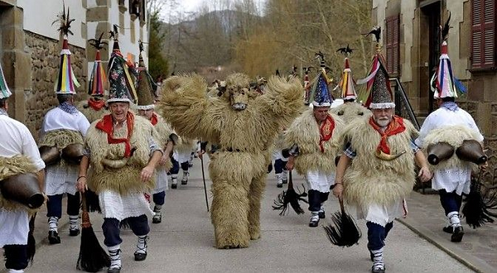

At a recent face-to-face gathering in Fryslan (much postponed because of Covid and associated restrictions) the working group leading on this initiative also decided to become an independent agency, while retaining close links with Celtic Neighbours and remaining ready at any time to collaborate in the future. The committee of Celtic Neighbours has welcomed this development, which enables us to concentrate our efforts on stimulating and supporting other fledgeling initiatives.
