Report on activities 2014 - 14

TOSTA
Thanks largely to the generosity od DSS2016, the TOSTA programme of artist residencies and travelling roadshow will be taking place throughout 2016. Celtic Neighbours is one of five core partners, with specific responsibility for network management and information flow, and for co-ordinating events within Wales. We are delighted that at almost the last minute, we’ve been able to draw in new partners from Cornwall and Galicia, ensuring that the project represents the vast majority of minority linguistic cultures in the north-west of Europe.
PROJECT ACTIVITIES
Following the great success of the Basque band ‘Bitartean’ who toured Ireland and Wales in 2013 and 2014, we invited the Galician piper, university professor and musicologist Xosé Manuel Sánchez Rei to visit north and west Wales for a flying visit this February. He performed to four sell-out audiences, made contacts with musicians and academics, and made friends wherever he went.
“The week in which I was in Wales was magnificent in every sense,” he commented afterwards. “I felt like in my own home. I will never be able to forget these days of friendship and music - and iechyd da...!.” We hope that Xosé Manuel will shortly be performing his magic in the west of Scotland, too. For news of other outcomes from his visit, please read on.
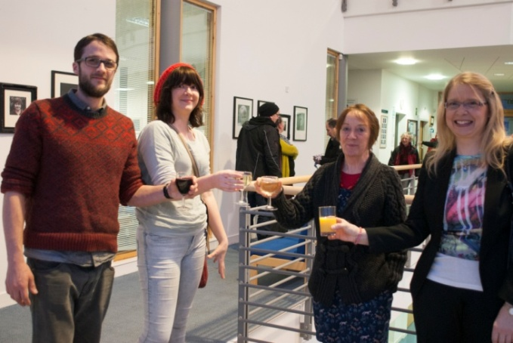
‘Clouds of Witness’, the community-based collaboration developed by Ciara O Flynn from Dingle and Naomi Heath from Ceredigion, was a huge success when shown at the Tannery Gallery of MoMA Wales in Machynlleth last Autumn. This March, a pop-up of the show returned to Sabhal Mor Òstaig in Skye, the Gaelic-language college of the University of the Highlands and Islands, where the artists began planning their interaction. There were very rewarding moments sharing the work with both children and adults – and then the show moved on for a month’s exhibition in May, in Lekunberri in the Basque Country, which was hugely successful, and has engendered two further exciting project possibilities – a youth drama exchange, and another international visual arts exhibition process.
In partnership with Fíbín in Connemara and Sabhal Mor Òstaig in Skye, we’ve recently launched an initiative to work with six young performers developing an innovative, accessible and participative multi-media cabaret show. This will showcase music, poetry, dance and more in Gaidhlig and Irish – and those languages alone. Designed primarily for younger audiences, "Craobh-abhainn" will make use also of the visual arts, and digital resources. After six months of preparation, it will tour first in Gaelic Scotland and the Irish Gaeltacht, and later we hope will be part of two European Capital of Culture celebrations – Donostia in 2016 and Leeuwarden in 2018. Both cities are committed to raising the profile of Europe’s smaller languages and cultures. Comcille, the partnership programme between Foras na Gaeilge and Bòrd na Gàidhlig, have offered financial support.for financial support.
Ruth Lambert, of MoMA Cymru at Y Tabernacl, Machynlleth, was so excited by the period of creative work shared there by Ciara O Flynn and Naomi Heath last year, that she has persuaded the gallery’s governors to include a regular, annual exchange of residencies between Welsh-speaking Wales and the Gaeltacht areas of Ireland. She and Eibhlín de Paor of Ealainn na Gaeltachta are hoping the first exchanges will take place in Autumn 2015 or Spring 2016. We are also in discussions with Elly Fletcher of An Lantairr in Stornoway, Isle of Lewis, and hope we can involve that gallery also in the exchanges.
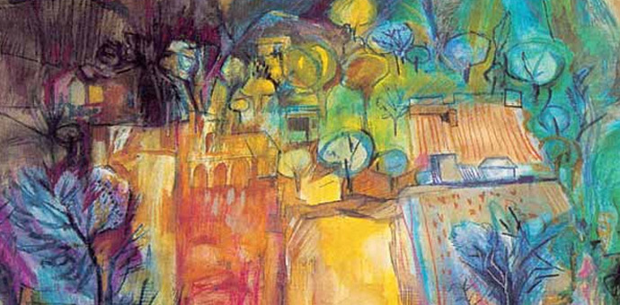

LANGUAGE SUPPORT
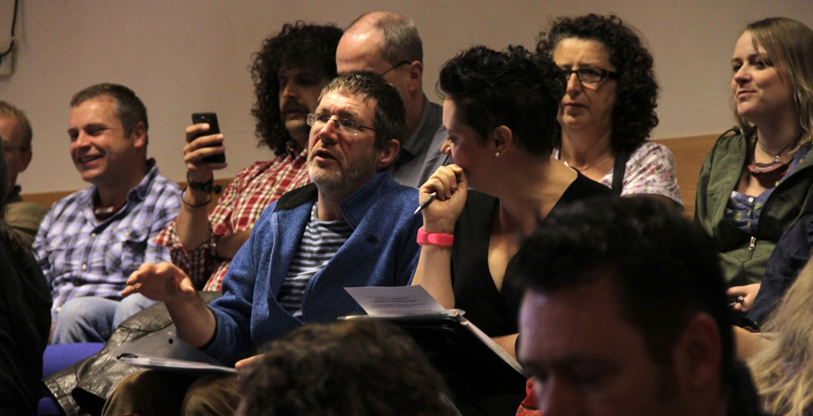
As our collaboration with our partners in TOSTA has grown deeper during the process of project development, we’ve often found ourselves confronting a challenge about language use – and it’s one which must affect thousands of others working in minority cultures. How can we talk to each other, relate to our other friends and stakeholders, and at the same time address a continent-wide audience, without always reverting to the world languages like English, Spanish and German? Words are the envelopes of culture, and we’re all aware of how much we lose from every interaction when we do this. At the same time, how do we prioritise our own languages and cultures without diminishing and excluding the many interested people without access to them? “If we don’t address the minority that is in everyone,” commented the Basque boat-builder Xabi Agote once, “and just talk to ourselves, we’re missing an enormous opportunity.”
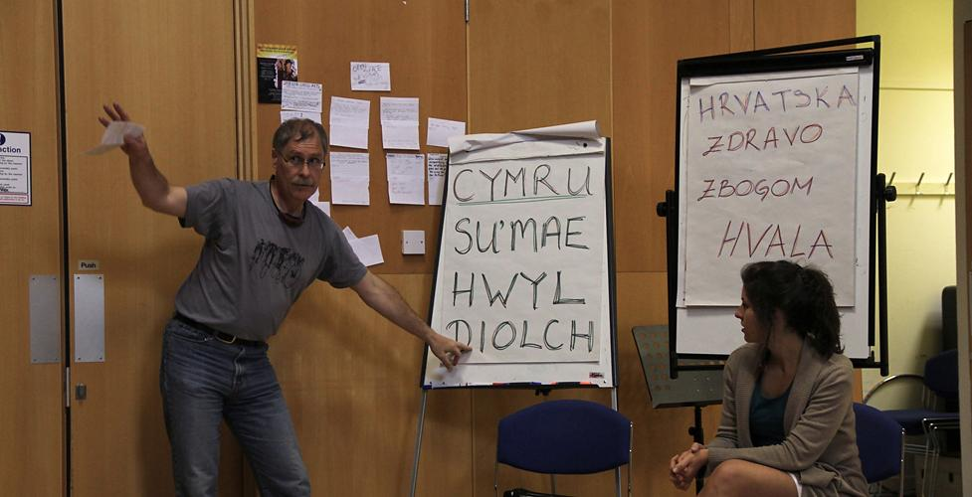
So we at Celtic Neighbours, with our partners across Europe, are determined to take every opportunity, as our relationships and activities continue to take shape, to develop a practice that maximises our use of all the smaller languages, while leaving doors and windows open and welcoming involvement in the big ones. This will demand enthusiastic research into emerging digital technologies, frequent interchange of ideas and opportunities, and also a commitment by all of us to begin learning and sharing each other’s languages. We hope by the end of this period to offer a template, which we might call ‘The TOSTA Template’ to other interested groups and organisations, to use and carry forward as they see fit.
Another initiative ‘ar y gweill’ – currently in development – is a three-way collaboration between partners in Frŷslan, the Basque Country and Wales to devise and compare materials that will empower community groups in all three countries to examine language and cultural provision in their neighbourhoods, compare results and work together on strategies.

TIONAL RESEARCH
As you all know by now, we were encouraged and financially supported by Highlands and Islands Enterprise to monitor the progress of the twenty-two collaborations that emerged from the TIOBAL gathering at Sabhal Mor Òstaig in Skye, in June 2013. We’ve maintained this process over the last eighteen months, and feedback from the sector on our report ‘Cultural collaborations and social regeneration’, distributed in October last year, has been very positive. We hope it will act as very powerful evidence on the powerful and sustainable impact – both economic and social – of grassroots cultural activity in small communities. Copies of the report, in both Gaidhlig and English, are available from post@celtic-neighbours.eu.

Eighteen months was not nearly long enough to chart the progress and effects of activities like these, and especially their economic effects. Se we’re delighted that further support has been made available, by Creative Scotland, the Arts Council of Wales, Udaras na Gaeltachta and Sabhal Mor Òstaig, to continue this research until the end of this summer. This has given us an evaluation period of more than two full years, and we are launching the completed report in Galway on 18th September this year.

